HEMC ASSEMBLY INSTRUCTIONS
- Sealing Nut Placement
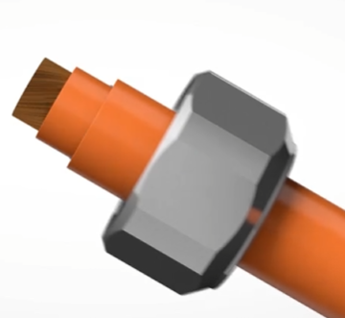
Before any cable preparation is done, the sealing nut of the cord grip must be slid onto the cable.

- Cable Preparation
  - The cable must be properly stripped and prepared for the assembly of the cord grip. The cable consists of four layers: the conductor, the inner jacket, the mesh shielding, and the outer jacket.
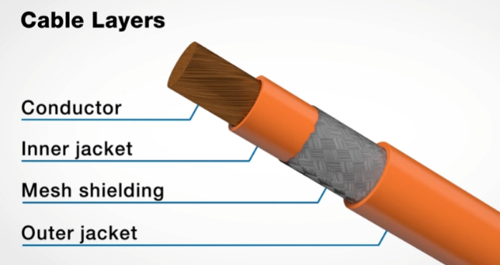

  - The mesh shielding will need to be exposed to install the crimp ring. After determining the location for the crimp ring, use a cutting tool to cut around the cable down to the inner jacket layer. Remove the outer jacket and mesh shielding up to this cut to expose the area that will be terminated.
  - Opposite the termination side of the cable, cut and remove the outer jacket and expose the mesh shielding. The length of mesh shielding exposed should be at least .370 inches (9,4 mm). The cable should now look like the picture shown below.
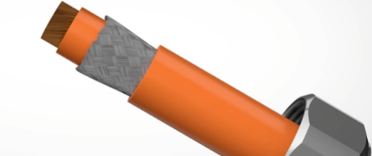

- Installing the Crimp Ring
  - Use the flange of the crimp ring to gently lift the mesh shielding away from the inner jacket of the cable.
  - Next, use the straight end of the crimp ring to flare the mesh shielding out.
  - Once the mesh shielding has been fanned out enough, lead with the flanged end of the crimp ring to fold the mesh shielding over the outer jacket. Ensure that the length of mesh shielding is completely encased by the crimp ring. At this step the assembly should look like the picture below, with the flange end of the crimp ring closest to the sealing nut and opposite the termination end of the cable.
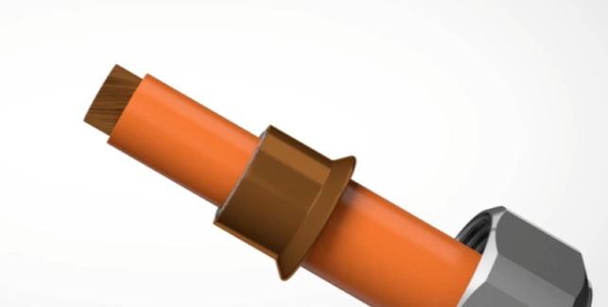

- Crimping the Crimp Ring
  - Ensure that the crimp jaws being used are the corresponding jaws for the crimp ring and wire size.
  - Insert the crimp jaws into the pliers.
  - Insert crimp and cable assembly into crimp jaws, ensuring the flange of the crimp ring is seated in the bottom half of the crimp jaws.
  - Close crimp jaws using the pliers and make sure that the crimp ring fully engages with the cable.

- Assembling the Cord Grip – Threaded Hole
  - Insert the cable through the body of the cord grip.
  - To ensure a liquid tight seal with NPT threaded fittings, a UL Listed Teflon tape or nickel plated brass compatible thread sealant is recommended to be applied to the threads prior to installation.
  - Using the body hex, screw the fitting tightly into the threaded mounting hole. To see Heyco’s Torque Chart (LTF’s, LTCG’s, SCG’s & Brass), visit the Cordgrips section on www.heyco.com for suggested torque values.
  - Insert the cable through the fitting to the desired position.
  - The crimp ring flange should seat into the inner lip of the cord grip body.
  - Assemble the split gland above the crimp ring, making sure that the interior lead in angle faces towards the body.
  - Slide the split gland down to seat correctly on the crimp ring.
  - Hand tighten the sealing nut as far as possible. Hold the body hex stationary with a wrench.
  - Check to make sure the body hex is held flush and tight to the chassis to insure a tight seal against the panel.
  - To disassemble, use a wrench to hold the body hex stationary and loosen the sealing nut with a second wrench. Grip the disconnected cable and pull while turning the cable in the counter-clockwise direction.
  - To replace a split gland, follow the same disassembly instructions but leave the cable in place.

- Assembling the Cord Grip – Clearance Hole
  - Insert the cable through the body of the cord grip.
  - The crimp ring flange should seat into the inner lip of the cord grip body.
  - Assemble the split gland above the crimp ring, making sure that the interior lead in angle faces towards the body.
  - Slide the split gland down to seat correctly on the crimp ring.
  - Tighten the sealing nut onto the body to Heyco recommended torque values.
  - Insert the fitting’s lower threaded portion through the mounting hole and hand-tighten the locknut as far as possible. Hold the body hex stationary with a wrench. Using a six-pointed socket or six-pointed wrench, tighten the locknut firmly in place. To see Heyco’s Torque Chart (LTF’s, LTCG’s, SCG’s & Brass), visit the Cordgrips section on www.heyco.com for suggested torque values.
  - Check to make sure the body hex is held flush and tight to the chassis to insure a tight seal against the sealing washer.
  - To disassemble, use a wrench to hold the body hex stationary and loosen the sealing nut with a second wrench. Grip the disconnected cable and pull while turning the cable in the counter-clockwise direction.
  - To replace a split gland, follow the same disassembly instructions but leave the cable in place.

